One To Watch Entry Form

Closing date for entries: 12th July 2024

This category is aimed at food and drink manufacturers or hospitality businesses who are less than 5 years old as at 1st January 2024 and is designed to recognise their potential for major growth, their future significant impact on the market and thereby raising the profile of Northamptonshire at a regional or national level.
(For businesses older than 5 years, please enter the F&B Achiever of the Year category.)

1. Business Contact Details:
This is how your business will appear throughout judging and in publicity material, were you to be successful in being shortlisted).
Business Name
Contact Name
Position
Business Address (inc. postcode)
Entrant Telephone Number
Entrant Mobile Number
Business Telephone Number
Email
Website
Twitter/FB/Instagram
Reg. Company No.

2. My Business | YES | NO
My registered business headquarters are in Northamptonshire.

3. Brief summary of your business
Please provide a brief summary of your business (in no more than 500 words):

4. Why are you the One To Watch?
Tell us in no more than 250 words why you believe that your business is the One To Watch, including details of your
current status in the market and your business growth plans for the next 2-5 years.

5. Personal Testimony
We may wish to contact up to two of your customers and/or staff to ask them to comment further on your status as the ‘One To Watch’. Please provide names and contact numbers/email addresses of those who would be willing to
assist us:
1 | Name
 | Tel No. |  | Email
2 | Name
 | Tel No. |  | Email

6. Supporting information
Please write your supporting information below. (It is not limited to the area you can see). Alternatively, you may provide up to ten sides of A4 (or comparable screenshots) containing other information in support of your entry e.g.
copies of project work. However, we cannot return any material.

7. Mandatory supplementary evidence
Have you submitted all mandatory supporting evidence (listed below) | YES | NO
- Commentary of no more than 250 words as to why you are a One To Watch.
- Names and contact details of those offering a personal testimony.
- Examples of promotional material (see limit on the amount).

Data Protection
By entering the Awards, you agree for us to store your details on our database and for us to contact you regarding all matters relating to the Awards. The database is accessed only by the Awards team and will not be shared with third parties, unless stated. If we are working with a partner whose work we believe may be of interest to you, we might share their information with you. If you would prefer not to be sent additional information by email, please let us know. You can removed from the Awards database at any time – please just email: awards@northamptonshirefoodanddrink.co.uk with UNSUBSCRIBE in the subject box and your name and contact details in the email.

Declarations
 | YES | NO
The details provided on this form and all supporting evidence are correct to the best of my knowledge and are submitted in accordance with the published Weetabix Northamptonshire Food and Drink Awards 2024/25 rules.
I agree to the details of my entry being passed to the category sponsors, to Trading Standards and my local Council’s Environmental Health Department.
I confirm the venue holds a Food Hygiene Rating Scheme score of 4 (Good) or above.
I authorise that my details may be subject to checks with Trading Standards and my local Council’s Environmental Health Department to disclose to the organisers and judges of Northamptonshire Food and Drink Awards any relevant significant history, complaints, or
breaches of relevant Regulations or law.
I agree to participate in awards-related publicity
Neither I nor anyone connected with my company has attempted to or will attempt to influence the organisers, judges, or promoter, or in any way bring the Awards into disrepute.
I confirm that this entry complies with the letter and the spirit of the rules of the competition.
I’m happy to receive emails relating to Food and Drink in Northamptonshire, including the Weetabix Northamptonshire Food and Drink Awards.
By entering, I am ‘opting-in’ to the Awards contacts database
Please send me emails about my entry into this competition only.

By typing/signing your name below, you are certifying that all the details submitted are correct to the best of your knowledge.

Signed |  | Date
Entries can be submitted by hand, post or emailed. All supporting information and postal entries should be returned to: The Mallows Company, Arch Villa, 23 High Street, Bozeat, Northamptonshire, NN29 7NF Tel: 01933 664437
Email entries to: awards@northamptonshirefoodanddrink.co.uk

You will receive an email confirming safe receipt of your entry – whether that is submitted by email or post.

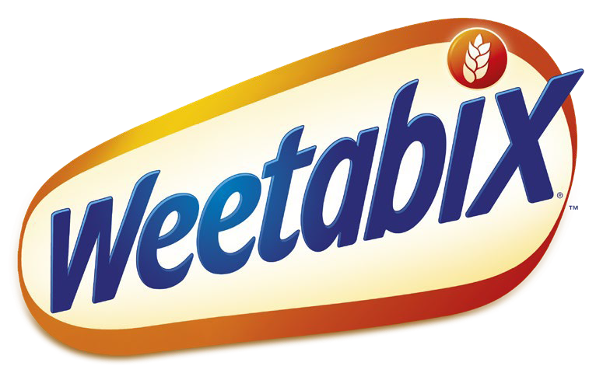

One To Watch

Entry
This category is open to all business owners of, or shareholders in, a food and drink manufacturer based in Northamptonshire. The judges ’decision about what constitutes a food and drink manufacturer is final.
Entries will be verified by the organisers to ensure compliance with the Terms and Conditions, and with the spirit of the
Awards. Organisers will use their best efforts to assist all entrants to comply with the Terms and Conditions but cannot be held responsible if for any reason an entry has to be disqualified or rejected.
Details of entries will be passed to Trading Standards and the relevant Council’s Environmental Health Department to disclose to the organisers and judges any relevant significant history, complaints, or breaches of relevant Regulations or law. The organisers will determine what action to take as a result of any such disclosure.

Shortlisting
A panel of judges will be looking for business people who, despite being in the early stages of their career in the food and drink sector demonstrate passion, commitment, talent and the commercial acumen to grow their business and ultimately contribute to the sector in Northamptonshire; they will consider all entries and will select a shortlist of finalists based on:-

- The entry form; including quality of the entry form and supporting material
- The nomination(s); the number and calibre of the nomination form (where appropriate)
- Compliance; including any advice received from Trading Standards Department and the relevant Council’s Environmental Health Department

Feedback from customers/staff

Each entrant will then be advised whether they have been selected as a finalist.

External panel
Each finalist will be interviewed to secure further information in support of their entry and an external panel will consider the results of those interviews and take into account the results of the shortlisting before determining who should be awarded Gold, Silver or Bronze. This is the morning of 10th September 2024. Please let us know if you are unable to attend this and alternatively could be conducted via Zoom.

The results will be announced at the Awards Dinner of which all finalists will receive one free ticket (maximum of one free ticket per company, irrespective of number of categories entered). Post Awards Gold Award winners will be invited to Business mentoring.

Key Dates

Closing Date

External panel interviews Awards Dinner
12th July 2024
10th September 2024 - morning
17th October 202
Finalists will receive one free ticket to the Awards Dinner with a nominal charge of £25 for the second ticket
and subsequent tickets will be charged at the higher rate.

Publicity
Please note, the details of those entries which were not successful in being shortlisted will not be made public; only the details of the finalists (and subsequently the results of the second stage Mystery Shopping) will be made public via our promotional material and via the Awards website – www.northamptonshirefoodanddrink.co.uk

You can also follow the Awards on Twitter and Instagram at @foodawardsHQ or on Facebook at @foodawards or on LinkedIn at @weetabixnfadawards

