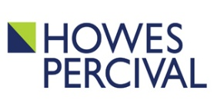
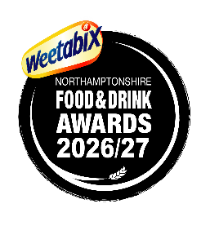

Local Food Hero of the Year

Entry Form
Sponsored by

Information
Closing date | 17th July 2026
This category is open to any organisation based in Northamptonshire; which also meets the following criteria:-
- is involved in the production of a food product or drink; or
- is involved in the food and drink sector in supplying, promoting, or selling local food goods or food services; or
- champions local, Northamptonshire products, drinks, food venues, or food markets; and who:-
- has a strong connection with their community; and
- is a ‘hero’ in the accepted sense of the word
- is involved in local food provision to those in need (i.e. food banks)

1. Nomination Category (please put an X in the appropriate box)
Business |  | Organisation |  | Person/Individual
Name, address and location of the above being nominated

2. Testimonial
I think that this person/business should receive the Local Food Hero of the Year 2026/27 Award because (not more than 250 words): Please enclose any other information you think will help us in understanding why your nominee deserves an award. (We are sorry but we cannot return any documents supplied.)

3. Your Details
Name
Address (inc. postcode)
Telephone number
Email

We cannot accept your nomination without some form of contact information and indeed, may wish to contact you for further details in support of your nomination, so please kindly ensure that you provide us with some way of contacting you.

Thank you for your nomination.

Please return it digitally or post by 17th July 2026 to Rachel Mallows, PO Box 8110, Wellingborough,
NN8 9NZ or email it to awards@northamptonshirefoodanddrink.co.uk

For more details about all the categories in this year’s Weetabix Northamptonshire Food and Drink Awards, please visit www.northamptonshirefoodanddrink.co.uk or call 01933 664437. You can also follow the Awards on X and Instagram at @foodawardsHQ or on Facebook at @foodawards or on LinkedIn at @weetabixnfadawards

